FOR IMMEDIATE RELEASE  Media Contact: Suzanne Hull  Iowa European Cultural Connection  suzanne.hull@iowaecc.org | 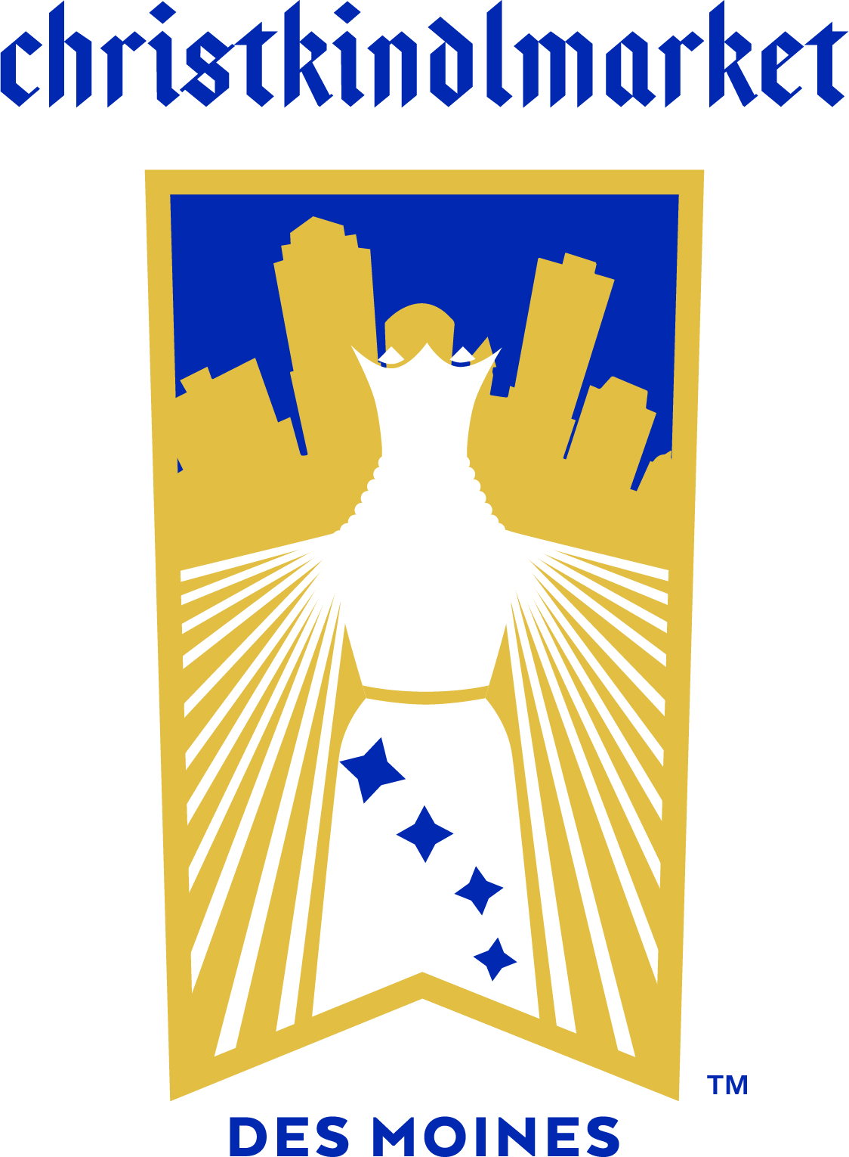

Christkindlmarket Des Moines Continues its Iconic Event

Preparations for the beloved annual family tradition are underway

DES MOINES, September 15, 2023 – The dates for Christkindlmarket Des Moines (CDM) 2023 have been announced by the Iowa European Cultural Connection (IECC) for November 30 – December 3 at Principal Park. Due to its continued success, #CDM2023 will continue its 4-day format with more amazing activities and 40+ vendors.

“We're excited to build upon our success from 2022”, Suzanne Hull the Director of Christkindlmarket Des Moines explains. “With our community’s support, we’ve grown to become the second largest festival of our kind in the U.S. based on average daily attendance.”

Since Christkindlmarket Des Moines began in 2016, this cultural experience has grown significantly. With the amazing quality and authenticity of the European traditions at CDM, it’s no surprise that it continues to grow. There is such a wide range of new and returning activities and vendors; from imported sweets and beer to traditional specialty items such as Steinbach nutcrackers and Glühwein mugs, the gift possibilities are endless.

The entertainment for this year’s festival is as impressive as the cuisine and handmade treasures offered. Yuletide Hall will be home to talented musicians and performers. In addition to German-style music, attendees will enjoy Irish dance groups throughout the entire 4-day festival. The opening performer will be the Jim Kucera Band which showcases German-style Polka & Waltz.

As a reminder to new and returning attendees, free surface parking is available west of Principal Park between SW 2nd St and SW 3rd St and south of W Martin Luther King Jr Pkwy. A map of parking options can be found on our website.

The festival is open to the public free of charge: Thursday, Nov 30, 5pm – 9pm, Friday, Dec 1: 11am – 9pm, Saturday, Dec 2: 11am – 9pm, and Sunday, Dec 3: 11am – 5pm.

IECC is always looking for enthusiastic volunteers, sponsors, and vendors to be involved and help CDM fully encompass the European holiday spirit. Visit our website https://christkindlmarketdsm.com for more information on volunteering, vendor applications and sponsor opportunities. All volunteers must be at least 16 years of age.

# # #

Christkindlmarket Des Moines 2023 Sponsors:

Due to the generous support of the Deb and Paul Hayes charitable fund, along with numerous donors and sponsors, we’re able to offer Christkindlmarket Des Moines free to our community. Sponsors include:

Prairie Meadows Casino, Racetrack, & Hotel, MidAmerican Energy Company, Bravo Greater Des Moines, The City of Pleasant Hill, EXIT Realty Capital City, Siegwerk USA Inc., Choice Creative Solutions, Duke Rentals, Chicago Teahouse, EMC Insurance Foundation, Lamberti, Kilian Luetje & Strong, P.C., Gilcrest/Jewett Lumber Co., Hessen Haus, Iowa State Bank, NB Golf Cars, TwoTone Creative, The Arlyn & Alice Hesse Family, Blake and Abby Kessler, Edward Jones – Ryan Kent, CFP®, Eisenlauer Real Estate, Greater Iowa Credit Union, Lincoln Savings Bank, The Rasmussen Group, The Härtel Family, M&M Family, Merrill Lynch, Pierce, Fenner & Smith Inc., Iowa Tourism Office, Daughters of Norway Eva Nansen Lodge 46, JR’s Southpork Ranch

The Iowa European Cultural Connection is a 501c3 tax-exempt non-profit that connects Iowans with European traditions, language education and cultural experiences.

Photos: https://bit.ly/45PXiml



