FOR IMMEDIATE RELEASE  Media Contact:  Suzanne Hull  Iowa European Cultural Connection  suzanne.hull@iowaecc.org | 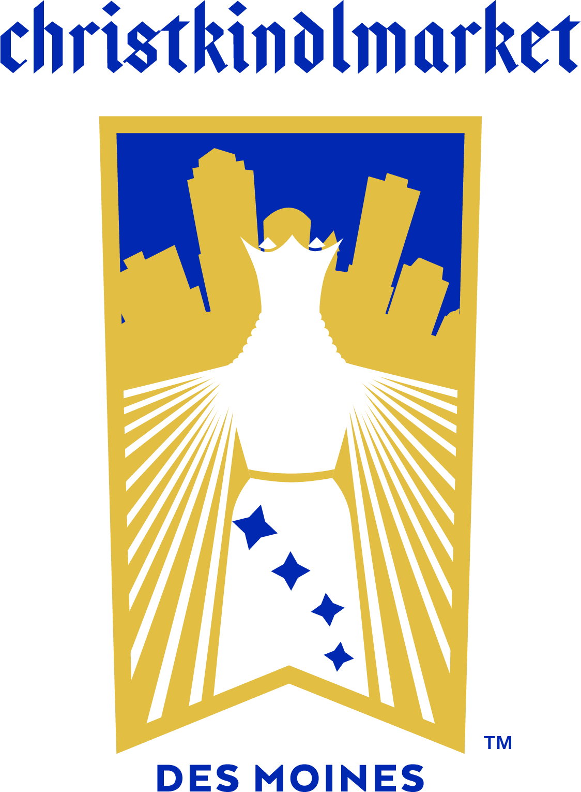

Christkindlmarket Des Moines Receives Support from EXIT Realty Capital City

EXIT Realty Capital City Sponsors Yuletide Hall Entertainment Stage

DES MOINES, October 26, 2023 – The dates for Christkindlmarket Des Moines (CDM) 2023 have been announced by the Iowa European Cultural Connection (IECC) for Nov. 30 – Dec. 3 at Principal Park. Event organizers are pleased to have the support of EXIT Realty Capital City this year.

EXIT Realty Capital City is comprised of a team of local real estate professionals committed to fast, professional and courteous service to help you understand and feel at ease throughout the home buying and selling process. Timothy Schutte, Broker/Owner and a long-time advocate of the European cultural experience shares, “I’ve seen this festival grow tremendously over the past six years and can’t wait to see what they have in store for their seventh season. We serve property buyers and sellers throughout Iowa and are pleased to be able to support this family tradition enjoyed by so many.”

“We're excited to build upon our success from 2022”, Suzanne Hull the Director of Christkindlmarket Des Moines explains. “It’s so important for us to have the support from our community and local businesses so we can continue to offer Christkindlmarket Des Moines free to all who wish to attend.”

Since Christkindlmarket Des Moines began in 2016, this cultural experience has grown significantly. With the amazing quality and authenticity of the European traditions at CDM, it’s no surprise that it has grown to become the second largest festival of its kind in the U.S. based on average daily attendance. There is such a wide range of new and returning activities and vendors; from imported sweets and beer to traditional specialty items such as Steinbach nutcrackers and Glühwein mugs, the gift possibilities are endless.

The entertainment for this year’s festival is as impressive as the cuisine and handmade treasures offered. Yuletide Hall will be home to talented musicians and performers. In addition to German-style music, attendees will enjoy Irish dance groups throughout the 4-day festival.

As a reminder to new and returning attendees, free surface parking is available west of Principal Park between SW 2nd St and SW 3rd St and south of W Martin Luther King Jr Pkwy. A map of parking options can be found on our website.

The festival is open to the public free of charge: Thursday, November 30, 5pm – 9pm, Friday, December 1: 11am – 9pm, Saturday, December 2: 11am – 9pm, and Sunday, December 3: 11am – 5pm.

IECC is always looking for enthusiastic volunteers, sponsors, and vendors to be involved and help CDM fully encompass the European holiday spirit. Visit our website https://christkindlmarketdsm.com for more information on volunteering, vendor applications and sponsor opportunities. All volunteers must be at least 16 years of age.

# # #

Christkindlmarket Des Moines 2023 Sponsors:

Due to the generous support of the Deb and Paul Hayes charitable fund, along with numerous donors and sponsors, we’re able to offer Christkindlmarket Des Moines free to our community. Sponsors include:

Prairie Meadows Casino, Racetrack, & Hotel, MidAmerican Energy Company, Bravo Greater Des Moines, The City of Pleasant Hill, EXIT Realty Capital City, Siegwerk USA Inc., Choice Creative Solutions, Duke Rentals, Thirsty Pigs, Chicago Teahouse, EMC Insurance Foundation, Lamberti, Kilian Luetje & Strong, P.C., Gilcrest/Jewett Lumber Co., Hessen Haus, Iowa State Bank, NB Golf Cars, TwoTone Creative, The Arlyn & Alice Hesse Family, Blake and Abby Kessler, Edward Jones – Ryan Kent, CFP®, Eisenlauer Real Estate, Greater Iowa Credit Union, Lincoln Savings Bank, The Rasmussen Group, The Härtel Family, M&M Family, Merrill Lynch, Pierce, Fenner & Smith Inc., Iowa Tourism Office, Daughters of Norway Eva Nansen Lodge 46, JR’s Southpork Ranch

Photos: https://bit.ly/45PXiml

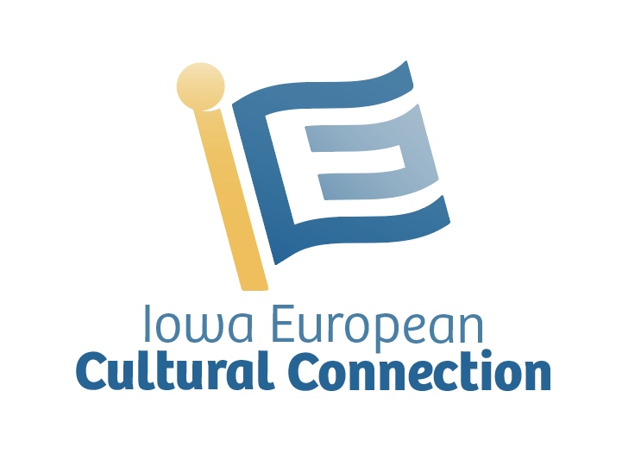
The Iowa European Cultural Connection is a 501c3 tax-exempt non-profit that connects Iowans with European traditions, language education and cultural experiences.

