FOR IMMEDIATE RELEASE  Media Contact: Suzanne Hull  Iowa European Cultural Connection  suzanne.hull@iowaecc.org | 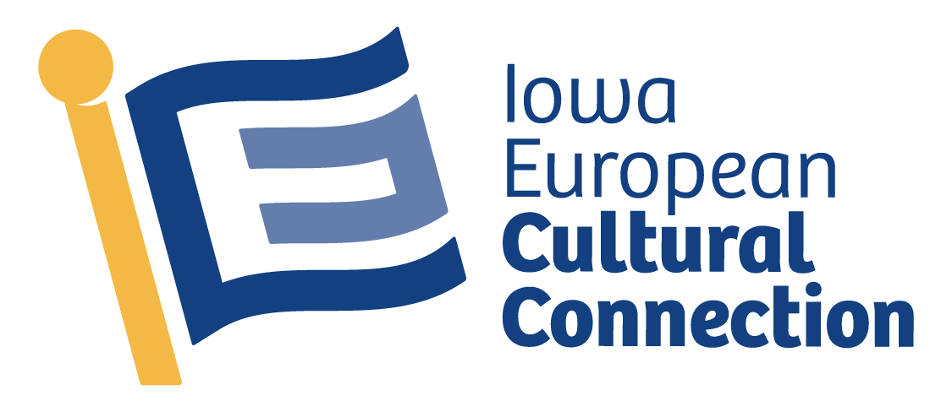

Experience Christkindlmarket Des Moines at New Principal Park Location

The festival grounds move to the parking lot north of the stadium for an expanded, redesigned experience

DES MOINES, September 12, 2024 – The dates for Christkindlmarket Des Moines (CDM) 2024 have been announced by the Iowa European Cultural Connection (IECC) for Dec 5 – 8 at Principal Park. With our community’s support, we’ve grown to become the second largest festival of our kind in the U.S. based on average daily attendance. Due to its continued success, #CDM2024 will continue its 4-day format with more amazing activities and 44 vendors.

“We're excited to build upon our success from 2023 with a move to the parking lot north of the stadium for an expanded and redesigned patron experience”, Suzanne Hull the Director of Christkindlmarket Des Moines explains. “In addition, we are hosting an afterhours in our enlarged, heated, entertainment tent from 9pm – 10pm on Friday and Saturday nights. Our festival attendees will also enjoy expanded food options, Breakfast with St. Nick (ticketed), new vendors, dedicated Glühwein refill lines, enhanced decorative lighting and additional free surface parking.”

Since Christkindlmarket Des Moines began in 2016, this cultural experience has grown significantly. With the amazing quality and authenticity of the European traditions at CDM, it’s no surprise that it continues to grow. There is such a wide range of new and returning activities and vendors; from imported sweets and beer to traditional specialty items such as Steinbach nutcrackers and Glühwein mugs, the gift possibilities are endless.

The entertainment for this year’s festival is as impressive as the cuisine and handmade treasures offered. Yuletide Hall presented by Prairie Meadows will be home to talented musicians and performers. In addition to various music styles, attendees will enjoy performances on Saturday and Sunday from the Schuhplattler Gruppe Edelweiss, which is the #1 award winning Bavarian Dance group in North America.

Patrons are invited to support local nonprofits by bidding on decorated trees in the Weihnachtswald (Christmas Tree Forest) presented by Siegwerk. The winning bidders can take home their trees and ornaments on Sunday at 5pm. The Kinderkorner tent presented by the MidAmerican Energy Foundation will host various children’s activities throughout the weekend.

Free surface parking is available west of Principal Park between SW 2nd St and SW 3rd St and south of W Martin Luther King Jr Pkwy and in the parking lot directly west of the stadium. A map of parking options can be found on our website. https://christkindlmarketdsm.com/parking/

The festival is open to the public free of charge: Thu, Dec 5, 5pm – 9pm, Fri, Dec 6: 11am – 9pm, Sat, Dec 7: 11am – 9pm, and Sun, Dec 8: 11am – 5pm. Yuletide Hall after hours 9pm – 10pm on Friday and Saturday.

IECC is always looking for enthusiastic volunteers, sponsors, and vendors to be involved and help CDM fully encompass the European holiday spirit. Visit our website https://christkindlmarketdsm.com for more information on volunteering, vendor applications and sponsor opportunities. All volunteers must be at least 16 years of age.

# # #

Christkindlmarket Des Moines 2024 Sponsors:

Due to the generous support of numerous donors and sponsors, we’re able to offer Christkindlmarket Des Moines free to our community. Sponsors include:

 | Bravo Greater Des Moines grant recipient
Yuletide Hall Sponsor | Prairie Meadows Casino and Hotel
KinderKorner Sponsor | MidAmerican Energy Foundation
Weihnachtswald | Siegwerk USA Inc.
Platinum Sponsors | City of Pleasant Hill  Community Choice  The Deb and Paul Hayes Charitable Fund  Duke Rentals
Gold Sponsor | Lamberti, Murphy & Strong, P.C.  Mittera Group
Bronze Sponsor | Gilcrest/Jewett Lumber Co.  Hessen Haus  TwoTone Creative
In-Kind | JR’s Southpork Ranch
Annual Hut Sponsor | The Arlyn & Alice Hesse Family  Blake and Abby Kessler  Chicago Teahouse  Daughers of Norway Eva Nansen Lodge 46  Edward Jones – Ryan Kent, CFP®  Eisenlauer Real Estate  GreenState Credit Union  Hessen Haus  Iowa State Bank
Vendor Stall Sponsorship | The Boesenbergs  The Härtel Family  Merrill Lynch, Pierce, Fenner & Smith Inc.  Prairie Meadows  The Rasmussen Group

The Iowa European Cultural Connection is a 501c3 tax-exempt non-profit that connects Iowans with European traditions, language education and cultural experiences.

Marketing and branding Kit: https://christkindlmarketdsm.com/about/marketing-and-branding-kit/
Submit your media inquiry AND see past media mentions: https://christkindlmarketdsm.com/about/media/
